**Topic Modelling- GoDaddy Tweets**

**Based on the Coherence Score vs Number of topics plot, ELBOW point having relatively minimum Coherence Score (Maximum Magnitude) was identified for 15 topics (Coherence score=-9.0132).**

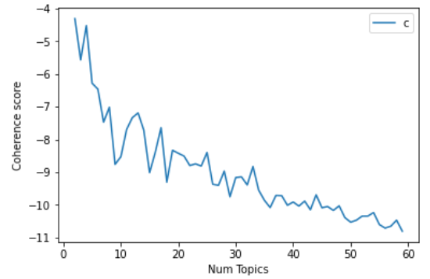

LDA plot for 15 topics had minimum overlapping circles!

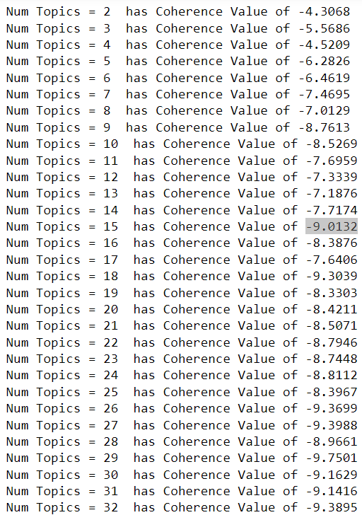

**15 topics/categories**

**1. First Circle/Topic**

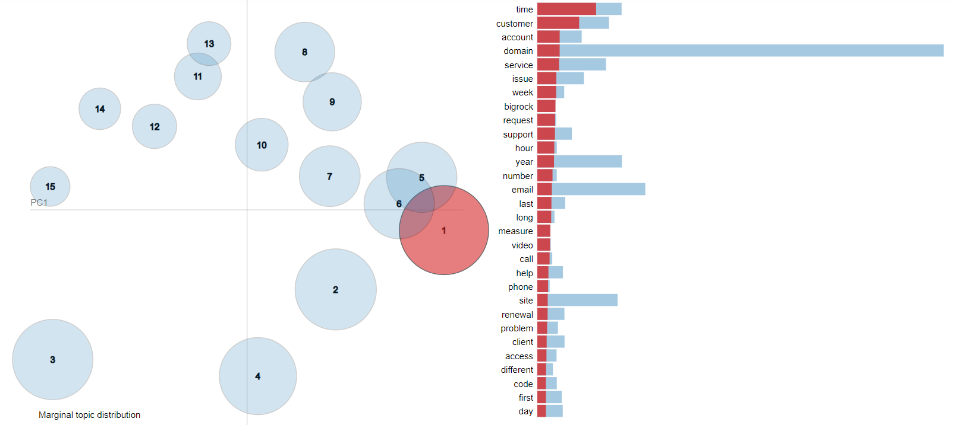

'0.052*"time" + 0.037*"customer" + 0.020*"account" + 0.020*"domain" + 0.019*"service" + 0.017*"issue" + 0.017*"week" + 0.016*"bigrock" + 0.016*"request" + 0.016*"support"'

**Possible topics for these keywords:**

1. Mention of a GoDaddy competitor 'BigRock' (an Indian web hosting company),

2. customer service/support by video calling/email/phone support

**2. Second Circle/Topic**

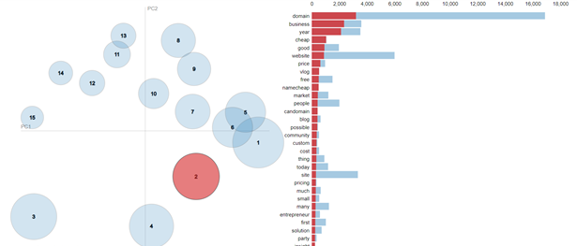

'0.082*"domain" + 0.060*"business" + 0.054*"year" + 0.027*"cheap" + 0.024*"good" + 0.023*"website" + 0.016*"price" + 0.014*"vlog" + 0.013*"free" + 0.013*"namecheap"')

**Possible topics(s):**

good & cheap/free business domain

Business – Vlogs/blogs etc.

**3. Third Circle/Topic**

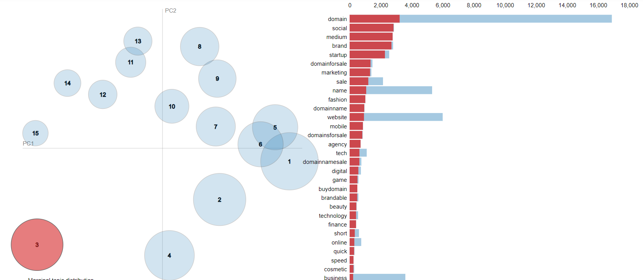

'0.085*"domain" + 0.074*"social" + 0.073*"medium" + 0.071*"brand" + 0.060*"startup" + 0.035*"domainforsale" + 0.035*"marketing" + 0.032*"sale" + 0.028*"name" + 0.027*"fashion"'

**Possible topics(s):**

domain names for sale… for social startups/brands

**4.**

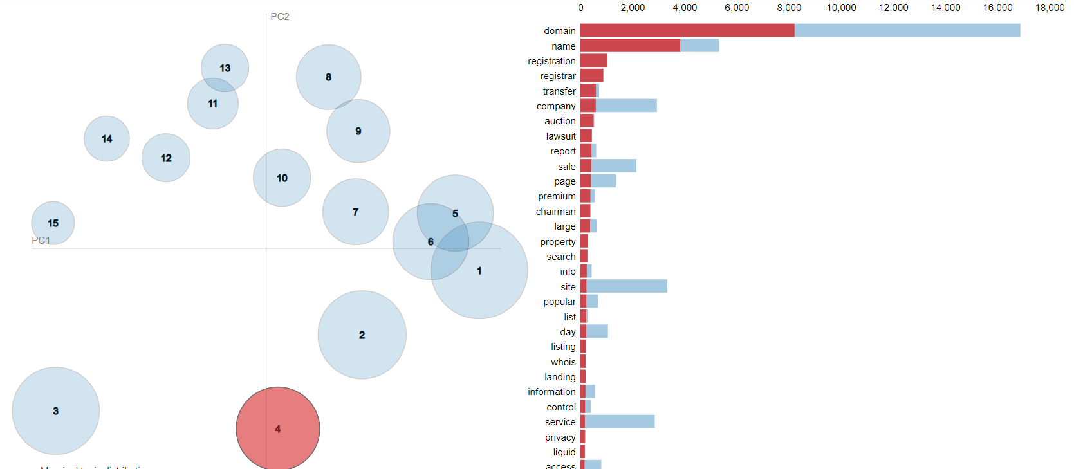

'0.234*"domain" + 0.109*"name" + 0.030*"registration" + 0.025*"registrar" + 0.017*"transfer" + 0.017*"company" + 0.014*"auction" + 0.013*"lawsuit" + 0.012*"report" + 0.012*"sale"'

**Possible topic(s):** 1.) Domain name Registration at Registrar; 2.) Domain name Auctions

3.) Sale/Transfer of company

**5.**

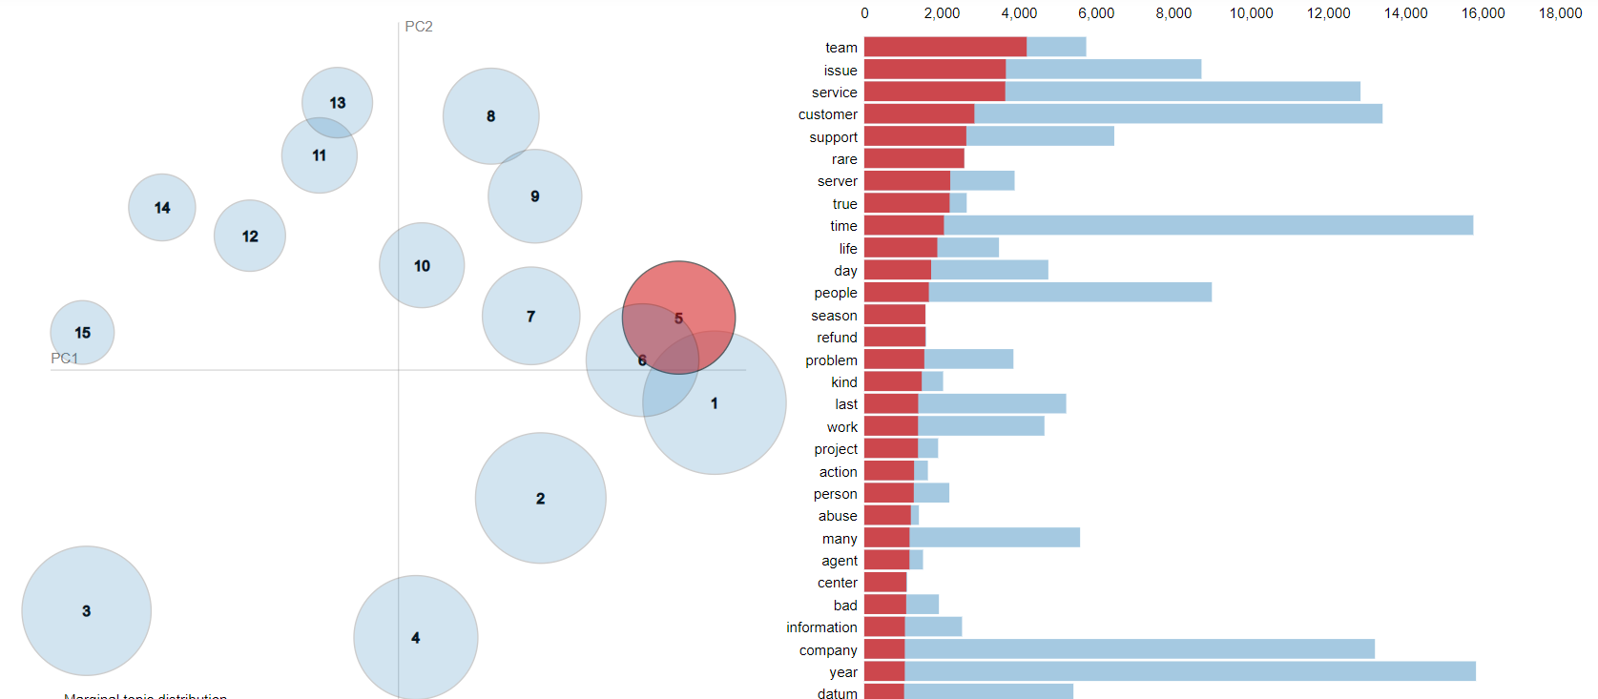

'0.032*"team" + 0.028*"issue" + 0.028*"service" + 0.022*"customer" + 0.020*"support" + 0.020*"rare" + 0.017*"server" + 0.017*"true" + 0.016*"time" + 0.014*"life"'

**Possible topic(s):**

1. Customer Service Support that caters to prob like refund, issues etc

2. true issues solved by customer service team

**6.**

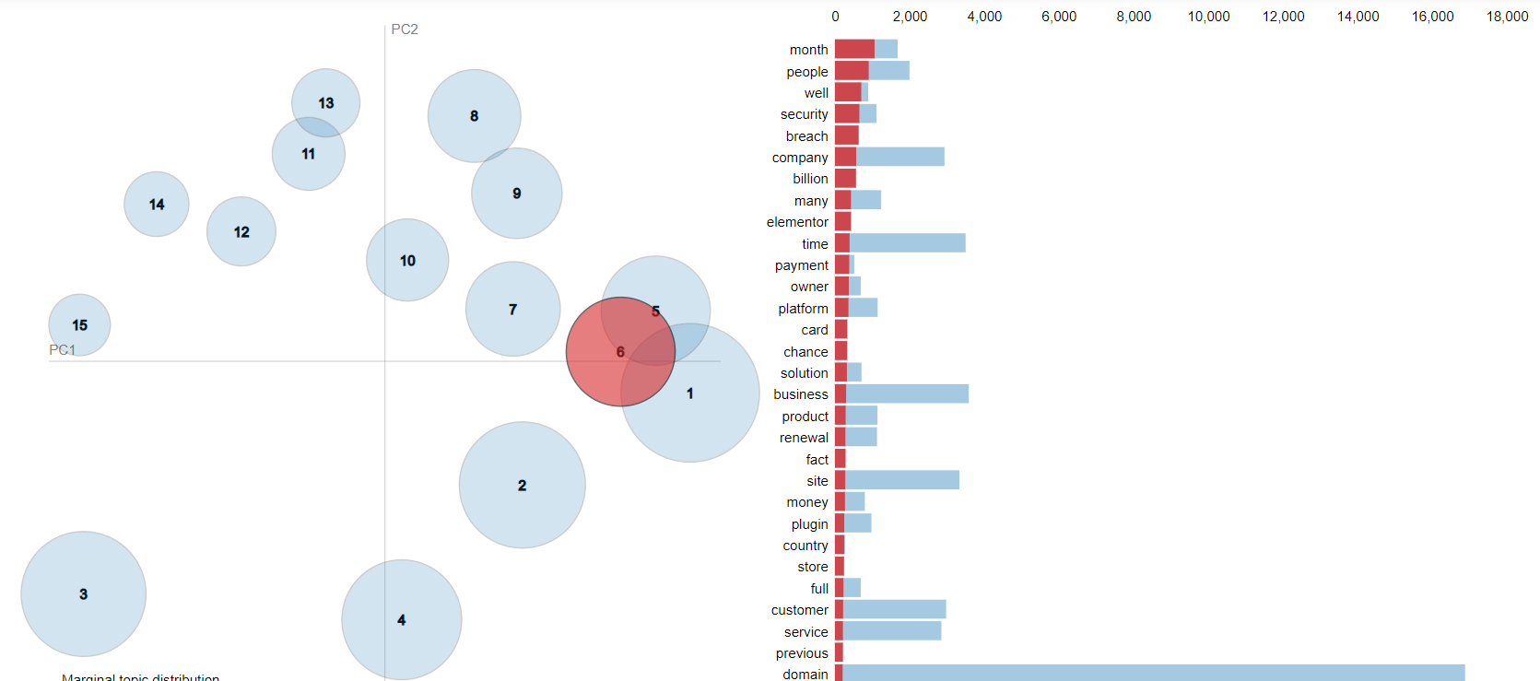

'0.037*"month" + 0.031*"people" + 0.024*"well" + 0.023*"security" + 0.022*"breach" + 0.020*"company" + 0.019*"billion" + 0.015*"many" + 0.015*"elementor" + 0.014*"time"'

**Possible topic(s):**

1. Security breach

**7.**

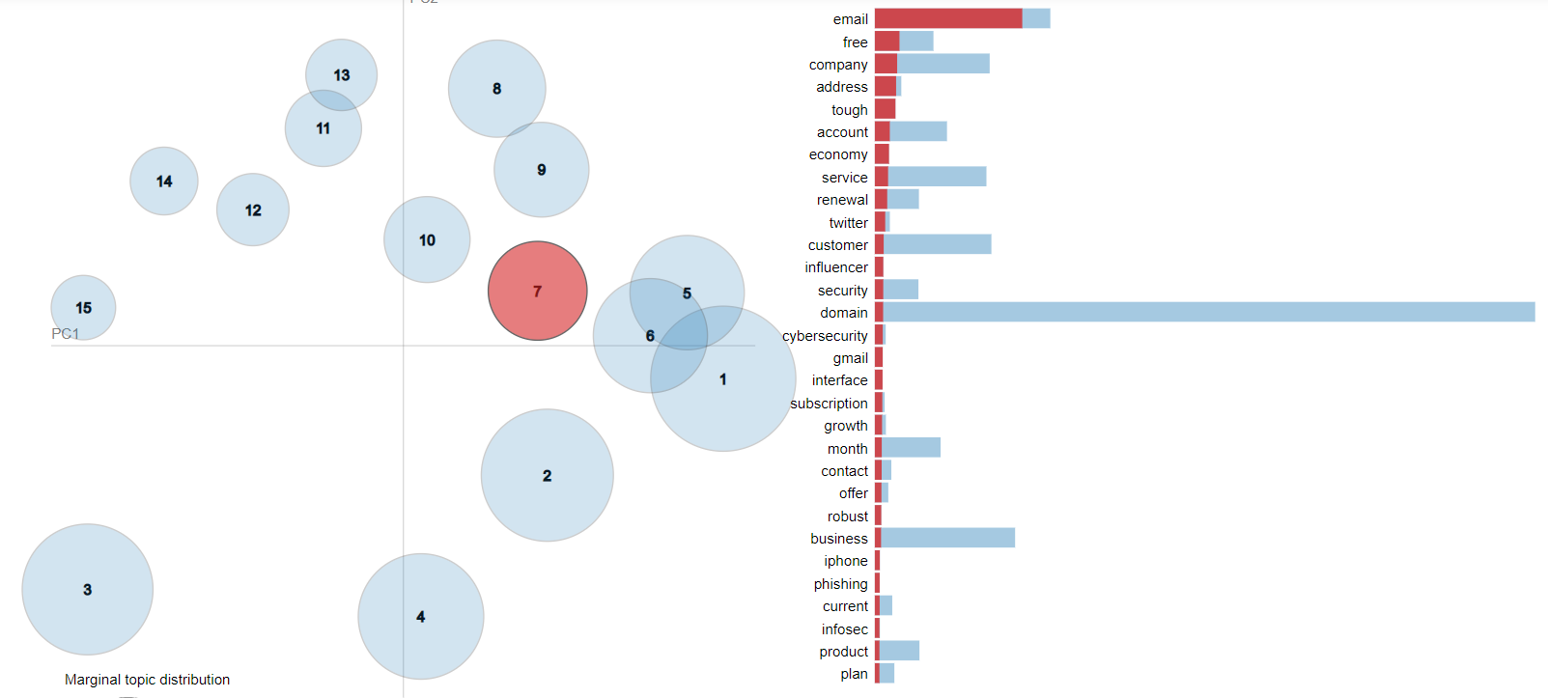

'0.173*"email" + 0.029*"free" + 0.026*"company" + 0.025*"address" + 0.024*"tough" + 0.018*"account" + 0.017*"economy" + 0.016*"service" + 0.015*"renewal" + 0.012*"twitter"'

**Possible topic(s):**

1.) Free email Service by company

2.) Economy Service renewal

**8.**

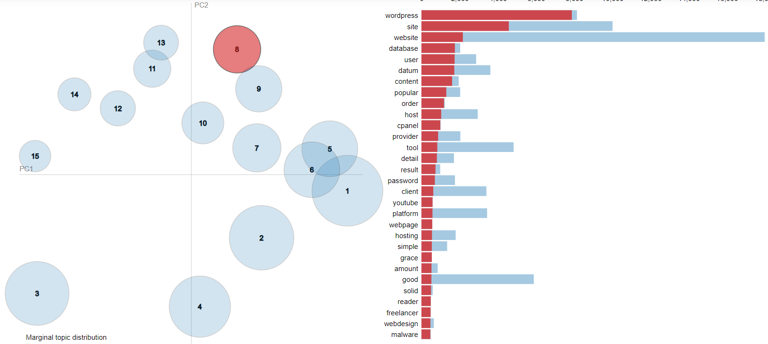

'0.125*"wordpress" + 0.073*"site" + 0.034*"website" + 0.028*"database" + 0.028*"user" + 0.027*"datum" + 0.026*"content" + 0.021*"popular" + 0.019*"order" + 0.016*"host"'

**Possible topic(s):**

1.) Hosting a website on WordPress

2.) User Database

3.) Talks about cpanel (competitor cPanel is a popular control dashboard that helps you manage your web hosting server using a human-friendly web-based interface.)

cPanel is a web hosting control panel software developed by cPanel, LLC. It provides a graphical interface and automation tools designed to simplify the process of hosting a web site to the website owner or the "end user".

**9.**

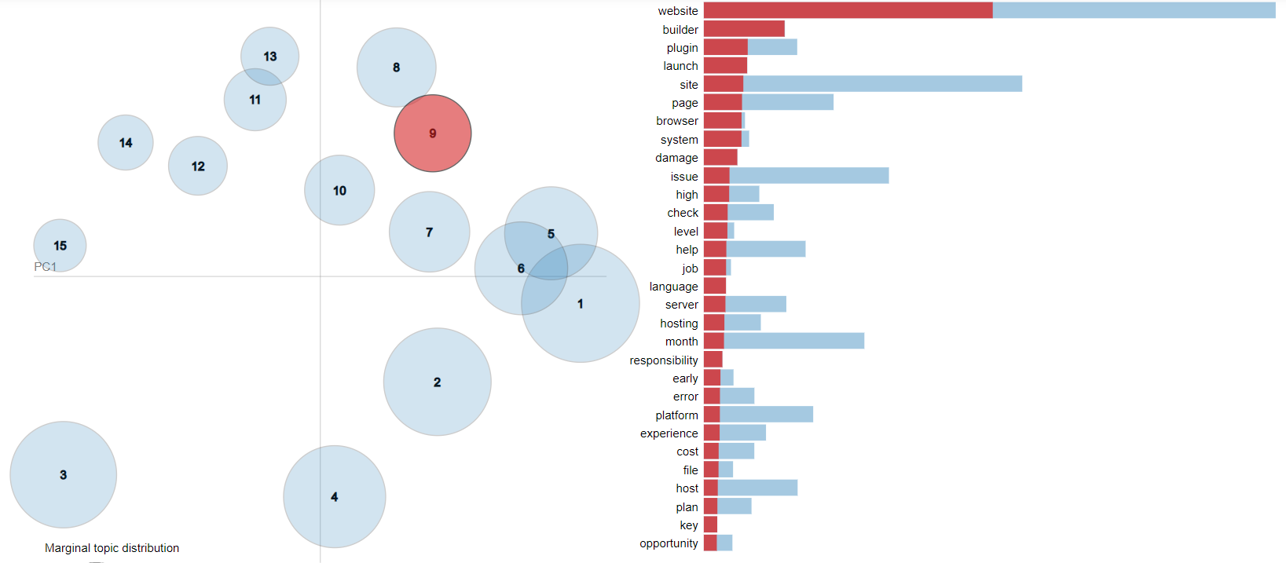

'0.152*"website" + 0.042*"builder" + 0.023*"plugin" + 0.023*"launch" + 0.021*"site" + 0.020*"page" + 0.020*"browser" + 0.020*"system" + 0.018*"damage" + 0.013*"issue"'

**Possible topic(s):**

1.) Website Builder, Site Launches

2.) Plugins for website building

**10.**

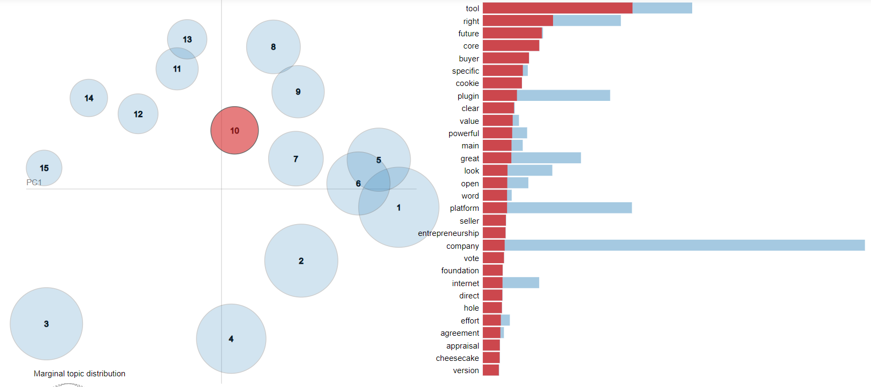

0.070*"tool" + 0.033*"right" + 0.028*"future" + 0.026*"core" + 0.022*"buyer" + 0.019*"specific" + 0.018*"cookie" + 0.016*"plugin" + 0.015*"clear" + 0.014*"value"'),

**Possible topic(s):**

1.) Building Right tools for specific Buyers

2.) Clearing Cookies, plugins

3.) Entrepreneurship

**11.**

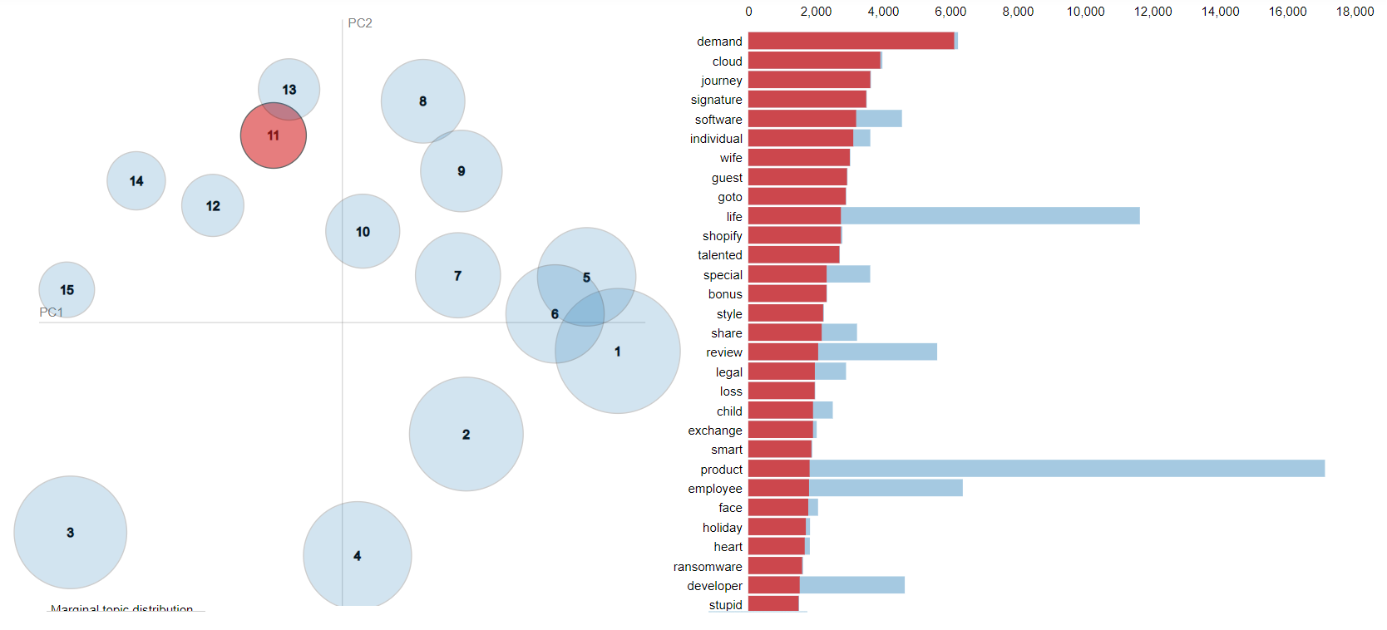

'0.031*"demand" + 0.020*"cloud" + 0.019*"journey" + 0.018*"signature" + 0.016*"software" + 0.016*"individual" + 0.016*"wife" + 0.015*"guest" + 0.015*"goto" + 0.014*"life"'

**Possible topic(s):**

1.) Demand of cloud, software signatures of individuals

2.) Makes a mention of Company ‘Shopify’ (Best e-commerce platform for online stores

**12.**

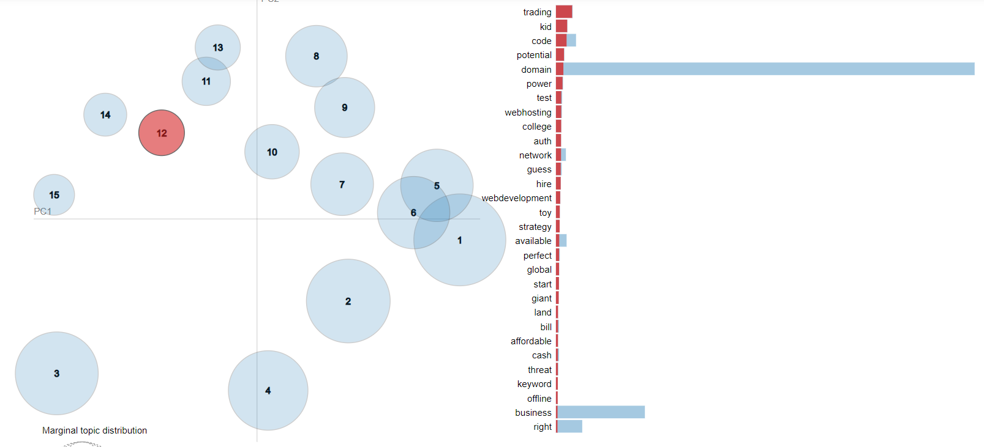

'0.056*"trading" + 0.039*"kid" + 0.037*"code" + 0.028*"potential" + 0.026*"domain" + 0.023*"power" + 0.019*"test" + 0.019*"webhosting" + 0.018*"college" + 0.018*"auth"'),

**Possible topic(s):**

1.) Potential domains for Trading purposes

2.) Webhosting/Web development

**13.**

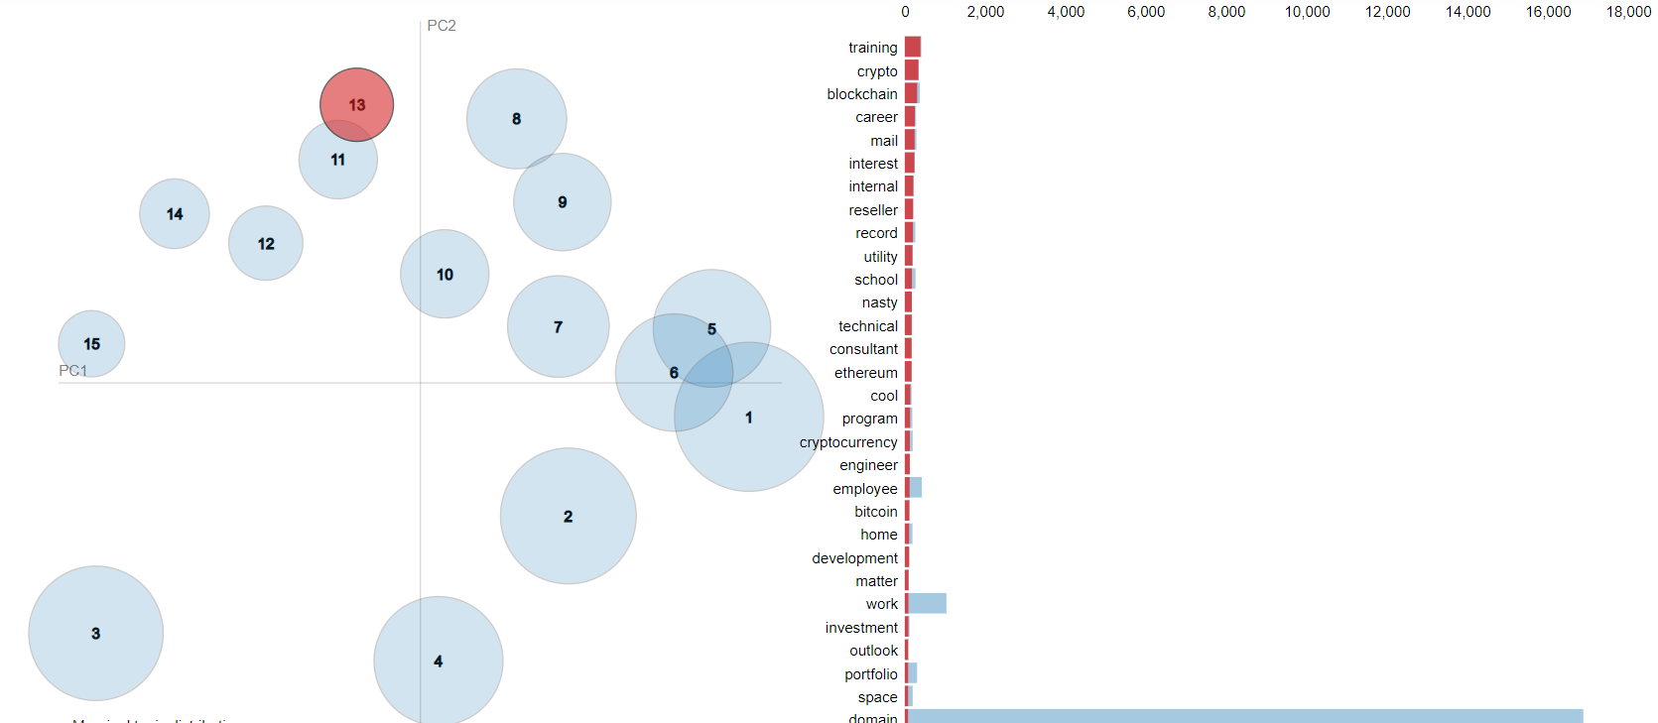

'0.035*"training" + 0.030*"crypto" + 0.027*"blockchain" + 0.022*"career" + 0.022*"mail" + 0.021*"interest" + 0.019*"internal" + 0.018*"reseller" + 0.018*"record" + 0.017*"utility"'

**Possible topic(s):**

1.) Crypto Currency

2.) Career interest in Blockchain training

**14.**

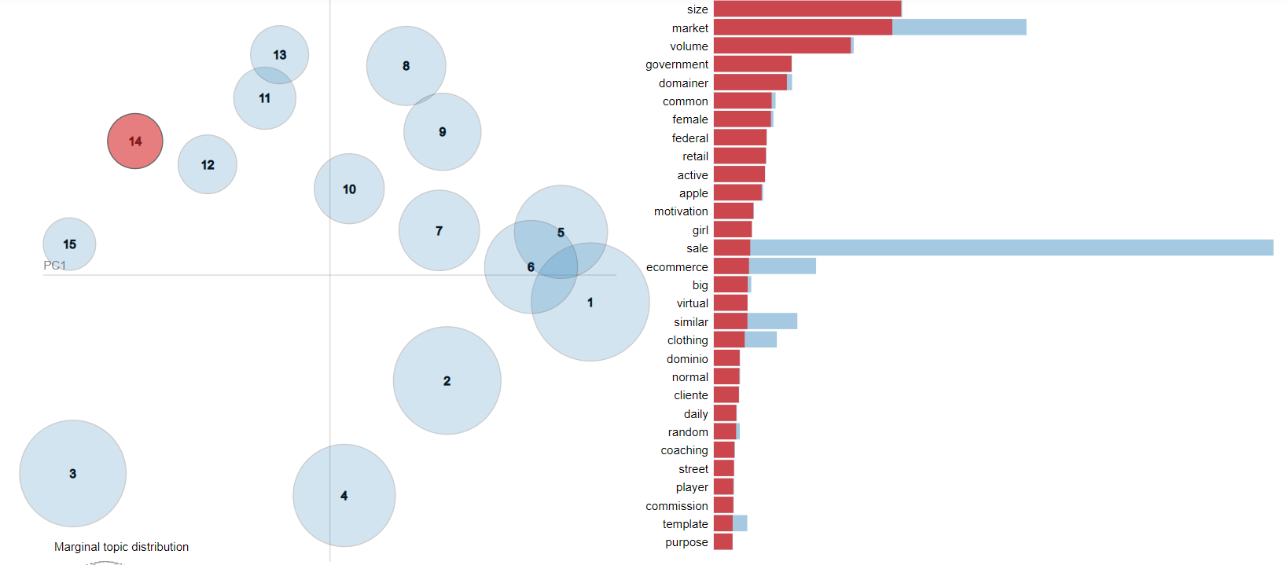

'0.071*"size" + 0.067*"market" + 0.052*"volume" + 0.029*"government" + 0.028*"domainer" + 0.022*"common" + 0.022*"female" + 0.020*"federal" + 0.020*"retail" + 0.019*"active"'

**Possible topic(s):**

1.) Market size/Volume of retail

2.) Govt/Federal domains

**15.**

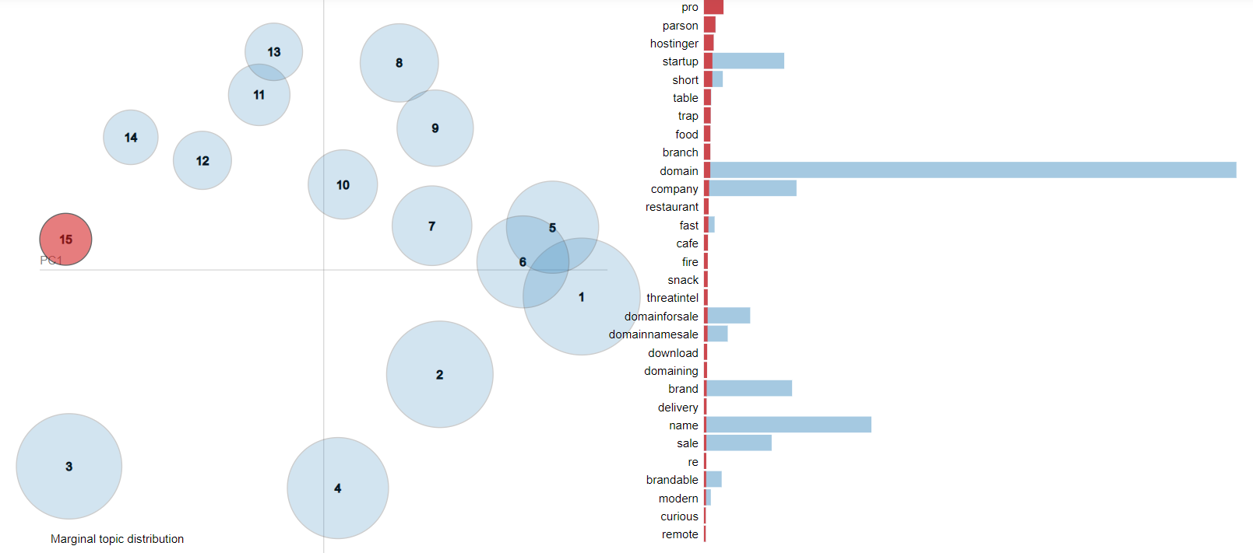

'0.067*"pro" + 0.040*"parson" + 0.033*"hostinger" + 0.029*"startup" + 0.029*"short" + 0.024*"table" + 0.023*"trap" + 0.022*"food" + 0.022*"branch" + 0.022*"domain"'),

**Possible topic(s):**

1.) Mention of competitor Hostinger (Web hosting Company)